- OBJECTIVE:
To lay down a procedure for hand washing.

- SCOPE:
This standard operating procedure covers the process of hand washing.
- RESPONSIBILITIES/ACCOUNTABILITIES:
- Staff, Visitors entering in production area shall be responsible to follow the process of hand washing procedure as per this SOP.
- Line leaders, House keeper, Supervisors, QA Officer are responsible for compliance of this SOP.

- ABBREVIATION AND DEFINITIONS
QA – Quality Assurance
SOP- Standard operating procedure

- PROCEDURES
- Employees are required to adhere to the following Hand washing procedures because good hand washing practices are essential for protecting yourself and products from contamination, germs, chemicals, and dirt that can accumulate on your hands throughout the day.
- All employees must wash hands at designated hand sinks.
- Wet hands and forearms with treated running water and dispense a small amount of hand soap onto the palm of one of your hands and then begin rubbing your hands together to distribute the soap.
- Scrub lathered hands and forearms, under fingernails, and between fingers for at least 10-15 seconds.
- Try to keep track of how long you are washing your hands to ensure that you are washing them for the right amount of time
- After finish lathering and scrubbing your hands, place your hands under the running water again and allow the water to run over them. Rinse away all of the soap from your hands thoroughly.
- Get rid of excess moisture from your hands. This can be accomplished by gently shaking your hands into the sink after you have finished washing them. The more moisture you remove, the faster it will be to use the dryer
- Dispense hand sanitizer to your hand and rub your hands together until the sanitizer evaporates. Cover both sides of your hands, between your fingers, and around your wrists.
- This should take about 20 seconds to do and the alcohol-based sanitizer will have dried on your hands by the time you are done
- Then Dry your hand with hand dryer provided
- All employees must wash hands at beginning of shift, after using toilet, after coughing, sneezing, using tissue or handkerchief, eating, drinking
- All employees must wash hands after doing other activities that contaminate hands, such as handling trash or chemicals.
- Animal Lab. Staff must wash hands after petting an animal, handling an animal, or handling an animal’s waste.
- The environmental staff must wash their hand after taking out the trash or picking up garbage
- All employees must sanitize their hands between glove changes and after touching hair or any body part except clean hands or arms.
- On each Shift, the line leader must ensure proper and frequent hand washing procedures are followed.
- Also the line leader must ensure that hand washing sinks are supplied with soap and hand sanitizer.

Materials, Equipment, Apparatus and Reagents
- IPA (70%)
- Liquid soap
- Running water
- Hand dryer

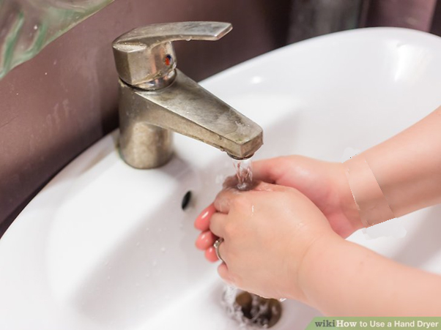

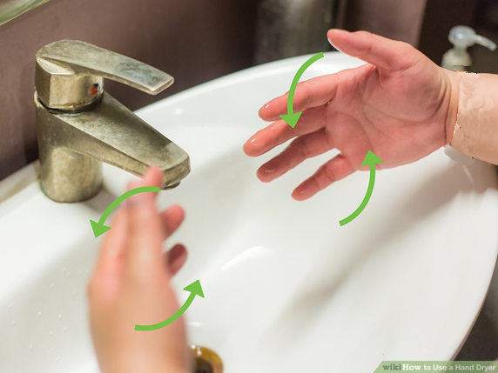

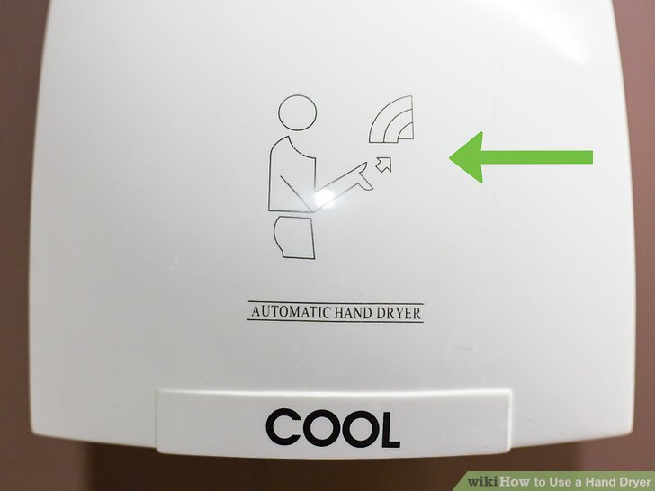

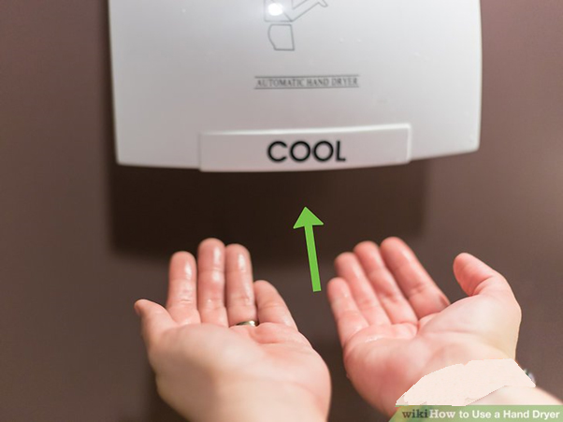

- REFERENCE AND ENCLOSURE
In- House Method

7.0 TRAINING INVOLVEMENT
All departmental managers | All sectional heads
QA and Admin staff | All staff

8.0 DISTRIBUTION AND CONTROL:
MASTER COPIES | QUALITY ASSURANCE
CONTROLLED COPIES | ALL DEPARTMENT

9.0 CHANGE HISTORY
CURRENT REVISION | SUPERSEDE | REASON FOR REVIEW
00 | Nil | First issue
06 | 05 | - Change in sop format.  - Inclusion of traceability of enclosures to parent SOP

